The Industrial Revolution III

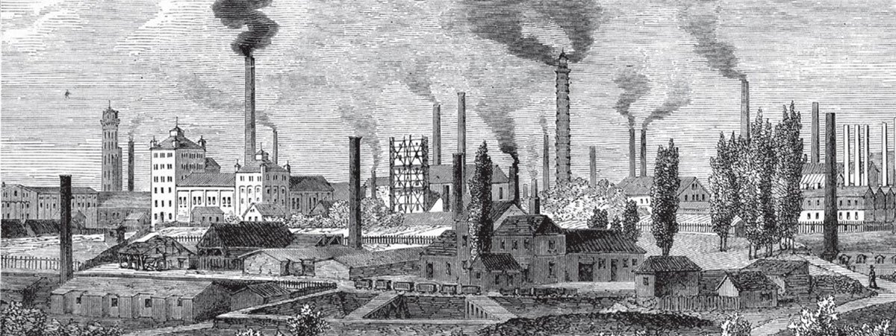
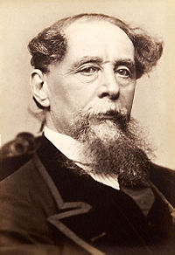
Oliver Twist MAVO/HAVO/VWO
Oliver Twist is a fictional novel written by Charles Dickens. In the story, Dickens describes the life of an orphan who lives in a workhouse in London. The book consists of several chapters and the reader is given a look into Oliver Twist’s misfortunate life events. After having been treated miserable in the workhouse, Oliver escapes and finds his way to London, where even more unfortunate events await him. It seems as if he can never catch a break. Luckily, there is one caring gentleman who takes Oliver into his home and treats him well.
Published in 1839, the story served as an outcry against child labour, conditions in workhouses and against the general living conditions during the Industrial Revolution.
Together, we are going to watch the beginning of the 2005 film adaptation of Oliver Twist. While watching, you have to answer the following questions:
- In a few words, describe what the streets look like when the man and the boy are walking towards the workhouse.

- Why is Oliver coming back to the workhouse today?

- What do the children in the workhouse have to do?

- Why is the boy in the room walking back and forth?

- The children are picking straws and Oliver picked the shortest straw. What does he have to do next?

- Why does Oliver have to do this?

- Why does the chimneysweeper stop at the workhouse?

- Oliver is about to be signed over to the chimneysweeper as an apprentice. What makes them change their mind?

- What do the two men demand happens to Oliver?

___________________________________________________________________________
After watching the video, answer the following question:
MAVO
Describe what happens to Oliver after he leaves the office. Use your imagination. Use 75 – 100 words for this.
HAVO
Imagine that you would have to do the same work as Oliver. How would you behave in the workhouse? What would you say to the other children and to the adult supervisors?
VWO
Describe the difference between the workhouse, the part where the children work, eat and sleep, and the part where the board is having their meals. Incorporate your opinion about this situation in your description.
EXTRA
Nowadays, it is illegal for children to do physical labour in Europe. However, there are still countries where children have to do hard work for very little money and in very bad circumstances. Go online and find out in what countries children still have to work and what kind of work they have to do.
___________________________________________________________________________

Diary entry MAVO/HAVO/VWO
Now that you’ve learned about the Industrial Revolution, about the factories, the people who worked there and in which circumstances, and know something about the workhouses, it is time for the next assignment.
You have to write a diary entry from a person of your choice. You can choose to write from the perspective of an adult man who works in a factory, an adult woman who needs to do all the housework and take care of the family, or from the perspective of a child (boy or girl) in one of the workhouses.
In your diary entry, you have to describe one day of their lives. Be detailed in your descriptions and include their surroundings (where they are), what they do, what they eat and how they feel.
In your text, include the following:
- Present tenses to talk about your person’s every day affairs.
- Past tenses to look back at previous events or days.
- Adverbs and adjectives
- Other grammatical structures to support your story.
You have to print your diary entry and hand it in for a mark.
Use 200 – 250 words for your diary entry.

